Fossils on different continents matched, suggesting the continents were once together

**Divergent Boundaries**

**Convection currents**

**Continental Drift**

Where two plates are moving towards each other

**Evidence for**

**Continental Drift**

Where a very hot mantle and weak spots in the crust cause “random” volcanos

**Pangaea**

**Oceanic**

**Hotspots**

Current in the mantle which causes plate movement

**Mantle**

When two plates are moving away from each other

Layer of the earth directly underneath the crust

**Convergent Boundaries**

**Transform boundaries**

**Crust**

Name of the super continent which existed 200MYA

Plate boundary which causes earthquakes but not volcanoes

**Outer core**

Denser of the two types of tectonic plates

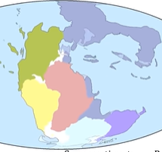

Theory that the earth’s crust is constantly moving (slowly)

**Transform Boundaries**

**Seismic waves**

Geological feature formed when two oceanic plates diverge

Theory that explains how tectonic plates interact

Another word to describe a plate boundary

Outermost layer of the earth

**Subduction zone**

**Fault**

Where a tectonic plate is forced under another plate

Waves of energy released by an earthquake

Where two plates are moving sideways against each other

Liquid layer within earth surrounding the inner core

**Plate Tectonics**

**Mid-Ocean ridge**

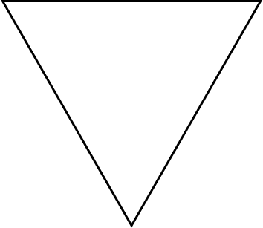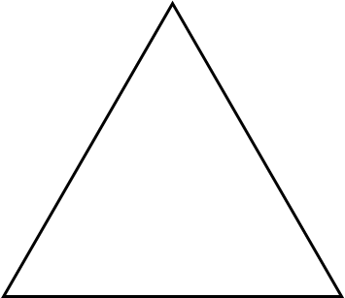

**Outer core**

Denser of the two types of tectonic plates

**Evidence for**

**Continental Drift**



**Hotspots**

Current in the mantle which causes plate movement

Fossils on different continents matched, suggesting the continents were once together

**Divergent Boundaries**

**Convection currents**

**Mantle**

When two plates are moving away from each other

**Continental Drift**

Where two plates are moving towards each other

Layer of the earth directly underneath the crust

**Convergent Boundaries**

**Transform boundaries**

**Crust**

Name of the super continent which existed 200MYA

Plate boundary which causes earthquakes but not volcanoes

Where a very hot mantle and weak spots in the crust cause “random” volcanos

**Pangaea**

**Oceanic**

Geological feature formed when two oceanic plates diverge

Where two plates are moving sideways against each other

Liquid layer within earth surrounding the inner core

**Plate Tectonics**

**Mid-Ocean ridge**

Theory that explains how tectonic plates interact

Another word to describe a plate boundary

Outermost layer of the earth

**Subduction zone**

**Fault**

Where a tectonic plate is forced under another plate

Waves of energy released by an earthquake

Theory that the earth’s crust is constantly moving (slowly)

**Transform Boundaries**

**Seismic waves**